­­­­

*Egyptian Red Crescent Documentation*

Course Name: Software Requirements & Specification

Course Code: SE392

Lecturer Name: Dr-Manar Hafez

Teacher Assistant: Eng- Ahmed Yosry Akrab

Team Members:

* Sarah Mohamed ID: 19107331
* Zaynab Salah ID: 19107901
* Salma Ayman ID: 19107447
* Mennatallah Ashraf ID: 19107209

**Purpose:**

Egyptian Red Crescent idea is a website to help connect hospitals and places in medical need with volunteers; it also offers courses to employees and volunteers in various medical fields as needed.

**Scope:**

The project is based in Egypt because that software affords an online database that organizes the data of serving, volunteering in medical fields in Egypt. This software is built for both the website and the mobile app.

**User Stories:**

* **Volunteer:**
* **User Story**

As a volunteer using the system, I want to be able to register my account in the first time.

I want to be able to log into the system to view the in need hospitals and make serve requests. I want to be able to view all the available courses and enroll in whichever I need.

* **User Needs**

As a volunteer:

* I want to be able to register on the system.
* I want to be able to log into the system.
* I want to be able to view in need hospitals
* I want to be able to make a serve request.
* I want to be able to view the available courses.
* I want to be able to enroll in courses.
* **Employee:**
* **User Story**

As an employee using the system, I want to be able to log into the system to add new cases and request the needed items. I want to be able to enroll in whichever course I need.

* **User Needs**

As an employee:

* I want to be able to log into the system.
* I want to be able to add cases to the system.
* I want to be able to request needed items.
* I want to be able to enroll in courses.
* **Admin:**
* **User Story**

As an admin using the system, I want to be able to log into the system to view the available ambulances and items. I want to be able to add new employees to the system.

* **User Needs**

As an admin

* I want to be able to log into the system.
* I want to be able to view available ambulances.
* I want to be able to view items.
* I want to be able to add new employees to the system.

**Business Objectives:**

* Ease of contacting hospitals with volunteers.
* Ease of learning in various medical fields.
* Reducing the time required to 60% to collect volunteers.
* Productivity of people and resources.
* Excellent customer service.
* Dealing with change.
* Reaching the right customer.

**Business Requirements:**

* **Functional Requirements:**

|  |  |
| --- | --- |
| Volunteer | 1. Registration  * Register to have account on system.  1. Login  * Login to access the system.  1. View Available Courses  * Display the hospitals that are in need of help.  1. View hospital in needed  * Ability to enroll in desired available courses.  1. Enrol available courses  * Request to serve in a specific field.  1. Serve Request |
| Employee | 1. **Login**  * Login to access the system.  1. **Add cases to system**  * Add hospitals ,issues, and situation to the system  1. **Request needed items**  * Request items that are needed in system  1. **Enrol in courses**  * Ability to enroll in desired available courses. |
| Admin | 1. **Login**  * Login to access the system  1. **View Available Ambulances**  * View available ambulances for demand.  1. **View Items**  * View available items in system  1. **Add new employees**  * Add new employee to system |

* **Non-functional Requirements:**

|  |  |
| --- | --- |
| 1. Privacy | Secure the data of system for volunteers, employees, and user data and data privacy. |
| 1. Response Time | High-speed response for request from user through secure system. |
| 1. Usability | Easy to use website or app for user to help them for their needs. |
| 1. Efficiency | The resources and good services that offered by system/app to help user. |
| 1. Concurrency | Support concurrent users, concurrent data to be easily updated. |

* **Fishbone Diagram:**

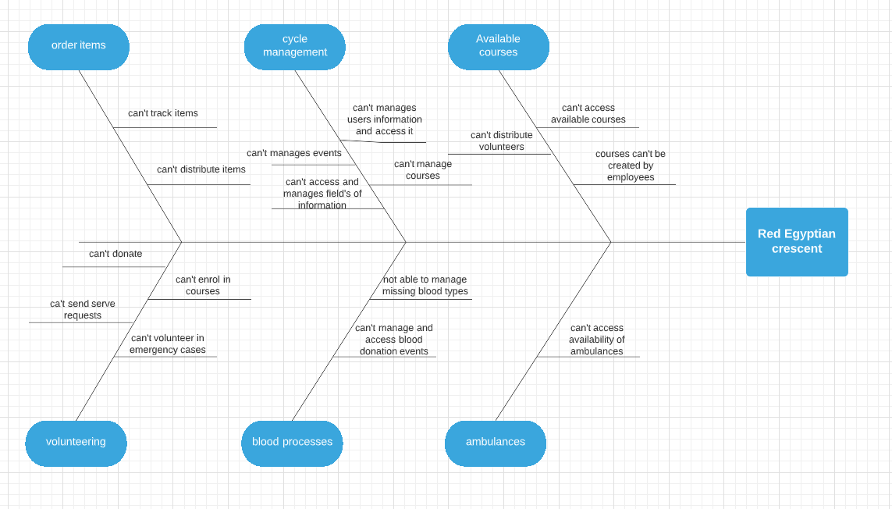

* **UML Diagrams:**
* Use-case Diagram

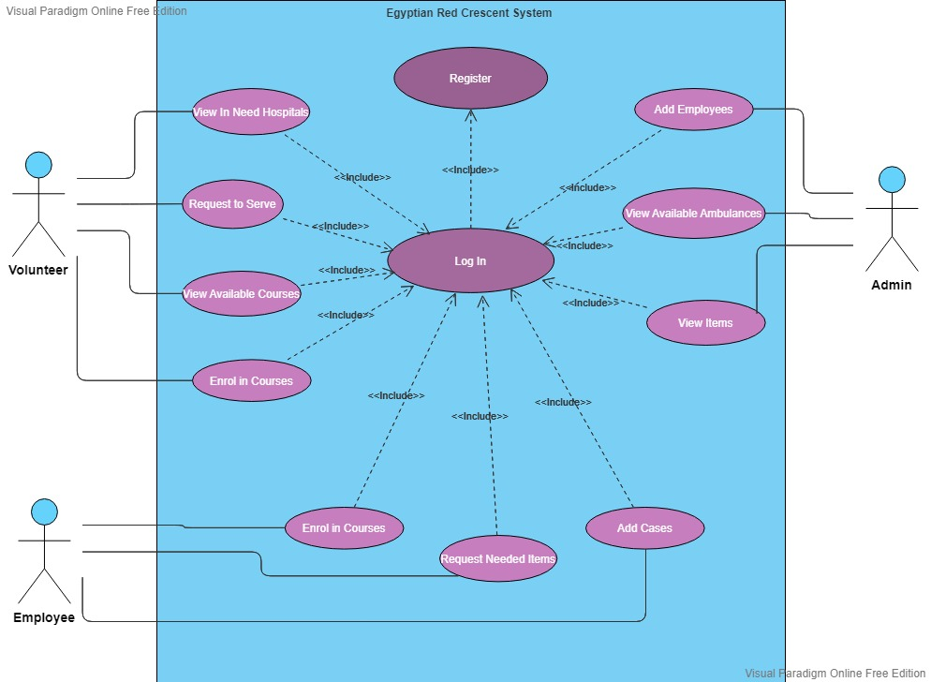

* Context Diagram

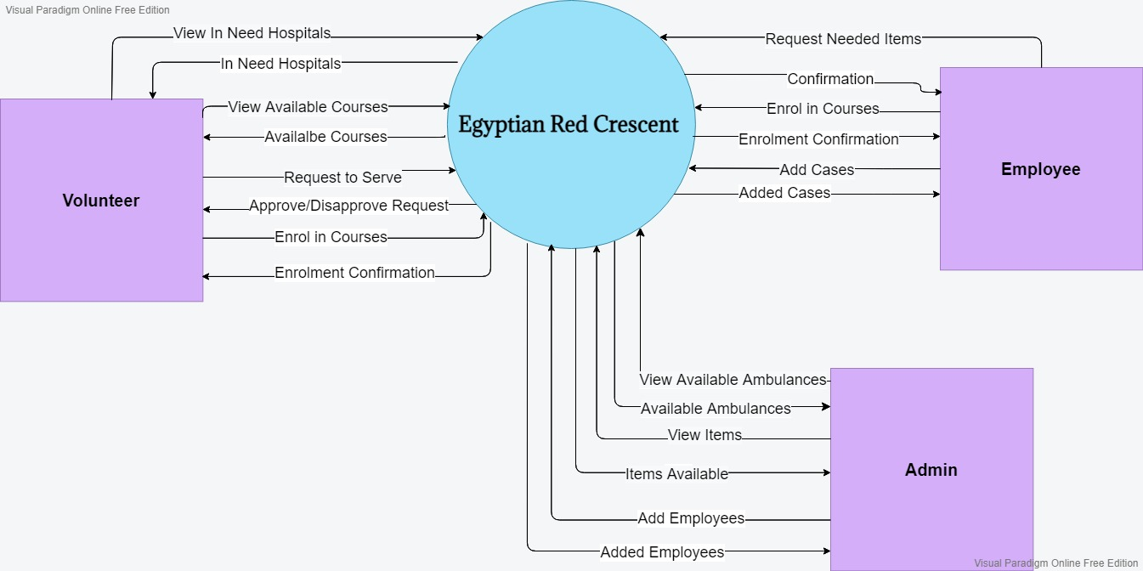

* Data-flow Diagram

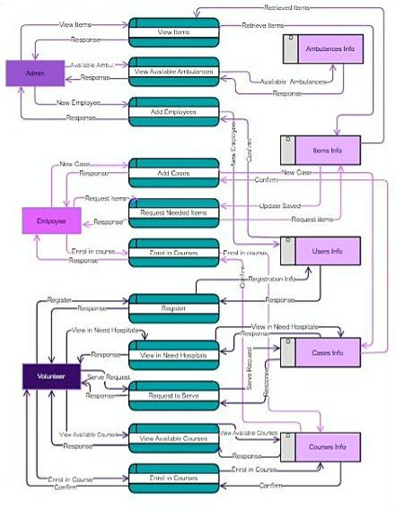

* **Prototype:**
* Welcome Page

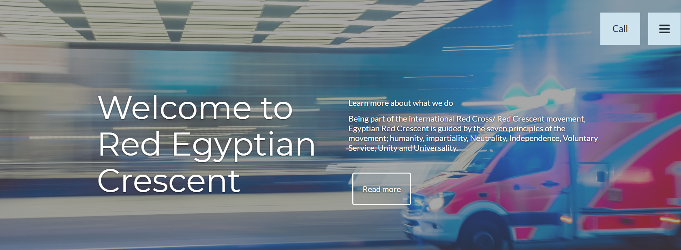

* Contact Me Page

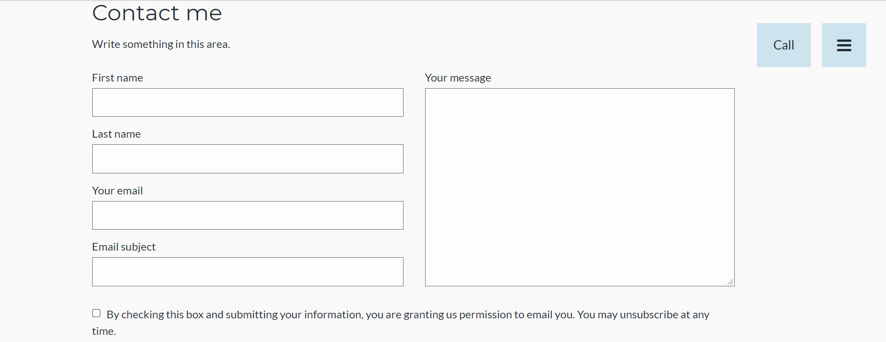

* First-Aid Course Page



* Volunteer Registration Page

